USER MANUAL
Thanks for purchase our Talking Flower Printer. This book mainly explains the capability, operation, setting and the connection of the printer. Please carefully read and abide this book before operate the Talking Flower Printer.
- Please make sure the computer has no connection with other printers, cameras or their drivers before using the Talking Flower Printer. The Talking Flower Printer may can’t work normally if there are other printers, cameras or drivers connected to the computer.
- When install the Talking Flower Printer, please install the camera driver first, make sure the Talking Flower Printer and the computer were connected by the USB line, then go next step. The system may can’t work normally if disturb this order.
- Please connect the Talking Flower Printer to the power before install the printer driver. Please follow the method and the photos in this book, otherwise, you may cause exceptional situation. (Photo 4.3 is the installation of printer driver)
- Please take care the packing of the Talking Flower Printer, don’t miss it. When you move the Talking Flower Printer, please well packing with the original items, otherwise, the problems caused by misuse or bad packing not include in the warranty.
ATTENTION
- This book has already detailed explained the capability, operation, setting, connection and other attentions, if you have any other questions, please contact us.
- Transship part or all the contents of this book without any permission is forbidden.
- Because of the different developing and producing period, the actual operation maybe a little different.
- During the using, some data may be destroyed or missing because of the data, hardware, misuse or some other reasons. Our company can’t assure completely, please copy your important data to avoid this situation.
- The usage of this book is to satisfy most of the customers, not for some customers’ specifically requirements.
- We are not considering the interference of some electronic devices, such as medical treatment devices, aviation universe equipments, and atom drive equipments during developing the Talking Flower Printer. We never take any responsibility if some accidents or property losses caused by these interferences during using the machine.
- The flowing items indicates the damages may occur under safety measure, if you don’t pay attention to these warnings and go on using the machine, we never take any responsibly of the losses caused by these., please read carefully before using the machine.

WARNING Indicates that if ignore this mark and go on misusing, you may cause accidents which lead to death or GBH.
ATTENTION Indicates that if ignore this mark and go on misusing, you may cause accidents which lead to body harm of property losses.
WARNING Please don’t open or repair the machine, monitor, wires and other attachments arbitrarily.
WARNING Please pay special attention during operation, any misuse may cause fire, please don’t destroy monitor, curve wires, or put some heavy things on the monitor and wires.
WARNING Please fix the internal attachments, wires and linker to the machine to avoid the children’s touch. Please don’t let the children touching the machine during operation.
WARNING Please don’t fix or change the parts inside the machine when the power on. Please change the ink cartridges when power off.
WARNING Please don’t touch the machine by wet hands, you may get an electric shock when power on or cause machine problem when power off.
WARNING If the machine smoking or emit peculiar smell, please cut the power of the computer and the machine at once.
WARNING Please don’t use the machine under following situation:
Under burning sun, in bath room, under strong magnetic filed, under static effect, under dusty, under vibration, on the uneven ground, in the hot gases, under the make water or creepage condition, in the place where deposited antiseptic or other harmful leechdom, in the very cold places. Please use the machine under10-40℃, relative humidity 65%-60%.
WARNING Please don’t drop liquid or put other objects into the machine, if you drop some liquid or other objects into the machine, put cut down the power at once.
WARNING The problems caused by man-made reasons not include in the warranty. Please don’t put anything on the machine.
WARNING To avoid fire, please cut down the power, disconnect the USB line when stop using.
ATTENTION The monitor is electronic device, it may produce static, please take care when uninstall. Please touch the machine carefully before using to avoid static.
ATTENTION Please don’t use the power supply and voltage not suit to the nameplate on the machine.
ATTENTION Please well packing the machine when you move or send back to us for repair.
ATTENTION Please don’t clean the machine by organic impregnant such as thinner, naphtha, please clean the linker.
ATTENTION Please obey the local law when you discard the machine.
ATTENTION OF INK CARTRIDGES
  - Please inquiry the original seller if you have any questions with the machine.
  - The valid use period is one year from purchase date.
  - During the validity, if you have any dissatisfaction with the machine, please come to the original sell for discussing.
  - The after-sale service is only under normal use, please correct use it according to the user manual. The problems caused by misuse, improper storage, over use or any change without our permission not include in the warranty.
WARNING Indicates that if ignore this mark and go on misusing, you may cause accidents which lead to death or GBH.
ATTENTION Indicates that if ignore this mark and go on misusing, you may cause accidents which lead to body harm of property losses.
WARNING Please don’t eat the ink in the cartridge, if eat by mistake, please see the doctor in time.
WARNING Please don’t drop the ink into eyes.
WARNING Please keep the ink cartridge out of the children’s touch.
ATTENTION Please don’t break librate, shake or knock the ink cartridge.
ATTENTION we don’t take any responsibility of the problems that caused by the change or the block of the ink cartridge.
ATTENTION Please don’t repeated use or change the ink cartridge.
ATTENTION Please don’t put the ink cartridge under strong sunshine, please keep in normal temperature.
ATTENTION Please use the ink cartridge during the validity.
ATTENTION Please don’t use other consumables except special colors and pre coats.

INDEX
I. Technical index 4
II. Installation 5
2.1 Open the CD to start the installation interface 5
2.1 Install Camera Driver 6
2.3 Install printer driver. 7
2.4 Install Gallery 10
2.5 Install Software 11
2.6 Close installation interface and restart computer 11
2.7 Test camera 11
2.8 Printer settings 12
III. Usage 15
3.1 Set Talking Flowers Program 16
3.2 Choose images from default gallery 19
3.3 Adjusting images and printing 19
3.4 Preview or delete selected images 20
3.5 Custom images 21
3.6 Word Edit 22
3.7 Picture Edit 24
3.7 Photo Taking 26
3.8 Printing 27
IV. Clean and change ink cartridge 30
V. Uninstall 33
5.1 Delete printer driver 33
5.3. Delete Talking Flower Gallery 34
5.4. Delete Talking Flower Program 35
5.5. Delete Camera Driver 36

Technical index
- Product size: 500mm×400mm×700mm
- Working condition:
  - Temperature: 10～40°C
  - Relative humidity: 50 ％～60％
- Voltage: AC 220V 50Hz or 110V/60Hz
- (Please check the nameplate on the machine for the details)
- Computer system (recommended) :
  - Operation system: WINDOWS XP
  - CPU: Intel Celeron600MHz and above
  - DDR Memory: 128M and above
  - VGA 24 bit resolution and support DirectX
  - CD-ROM
  - HDD 1G space (decide on the gallery)
  - 2 USB 2.0
  - Monitor solution: 1024 x 768 pixel; Color quality: highest (32bit).

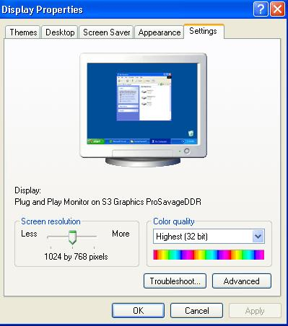
Drag to edit
Select
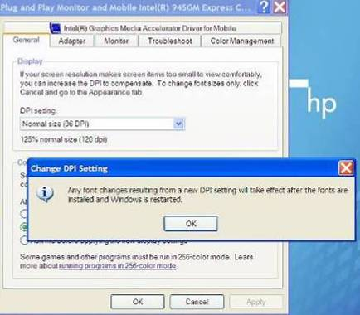
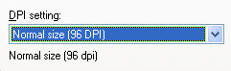

Installation

Open the CD to start the installation interface
Put the Talking Flowers software CD into CD-ROM, the system will appear the following interface automatically. If not appear the following interface, please preview the CD, then double click “Autorun.exe”.

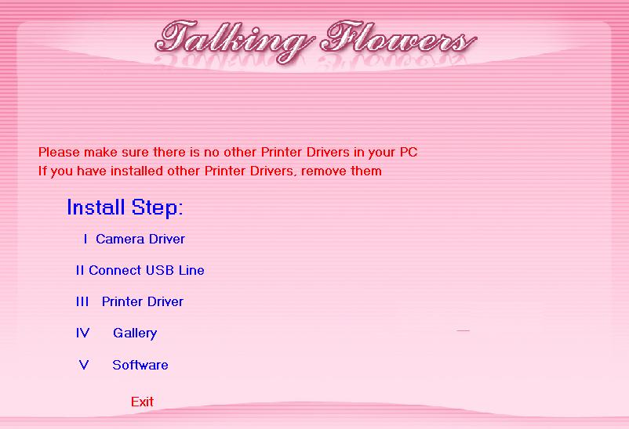

Install Camera Driver
  - Left click to start “Camera driver”
  - Click “Install”
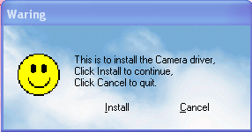
  - Click “Next”
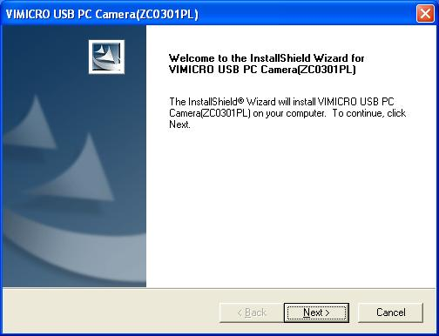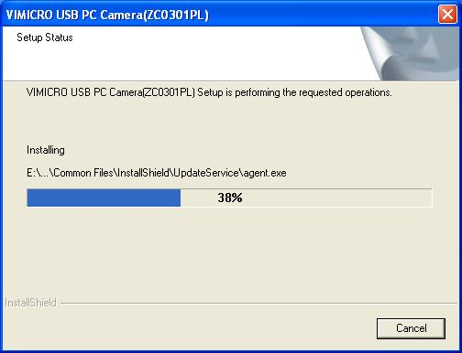
  - When appear the following dialog box, please
a. Please connect the camera USB line (the black, with “camera” label) to the computer USB port.
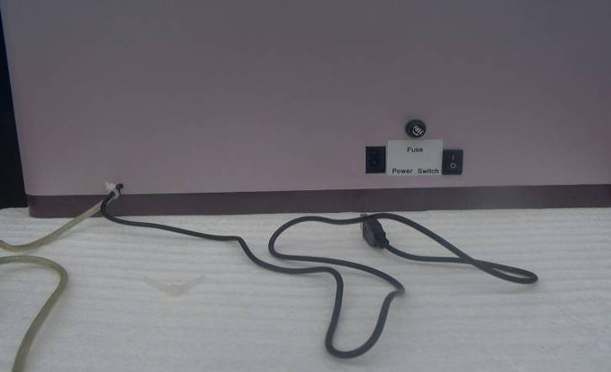
Insert to computer USB port
b. Please choose the “Yes, I want to restart my computer now.” and click “Finish”.
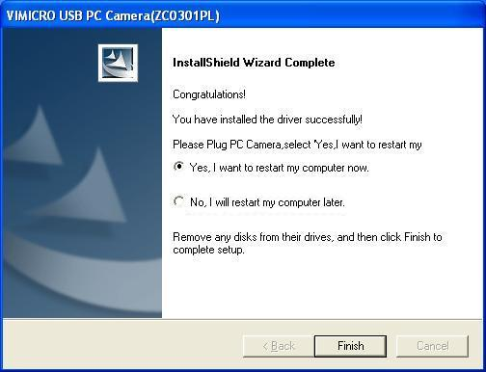
Click finish
Choose this
  - After restart the computer, the camera will work up to snuff.

Install printer driver.
- Connect power
- Please connect the machine power line (black) to the power supply.
- Please connect the attached power line to the supply.
- Please connect the power line to the socket.
- Turn on the switch on the back of the machine.(The machine may has some sound at this time, this is normal)
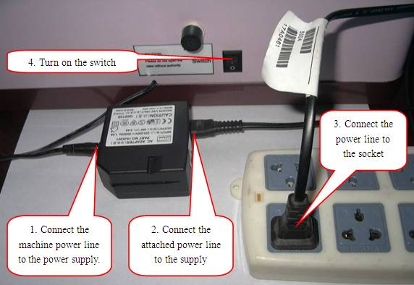
- The “printing status light” inside the machine will be bright also.
ATTENTION:
1. If the “printing status light” is not on, please press “printing switch” about 2 seconds, then release.
2. Press “printing switch” longtime is forbidden, otherwise, the printing system will be problem.
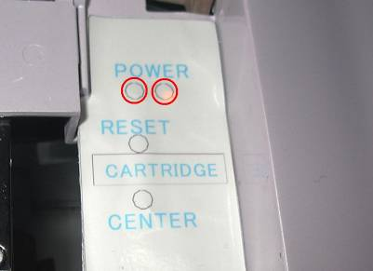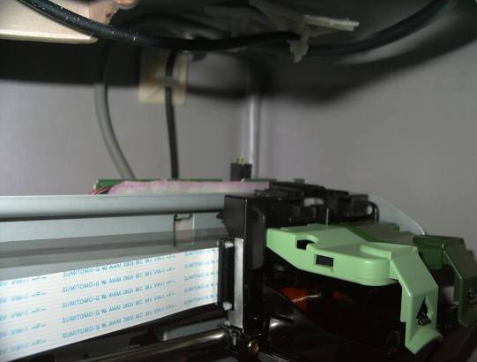
Printing status light
Power light on
Printing Switch
- Install the Ink Cartridge
  - Press the “center” button on the machine, the cartridge plate will move to center.
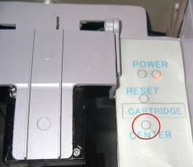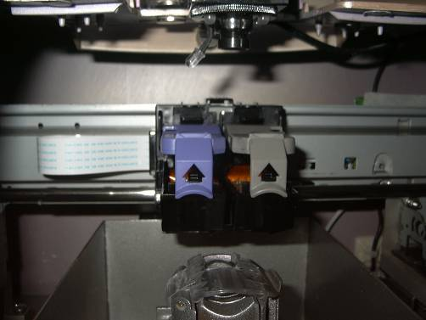
  - Open the lid of the left carrier
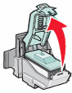

  - If you install the new ink cartridge, please remove the sticker first as follows:
ATTENTION: Please don’t touch the golden area on the ink cartridge.

  - Please put the ink cartridge into cartridge plate, and close the lid.

  - Press “Reset” button, the cartridge plate will go to the original place.
- Connect printer USB line
- Connect printer USB line (white, with “printer” label) to the computer USB port.
- Click “Cancel”, close the “Found new hardware” windows.
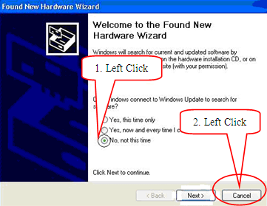
- Install printer driver
- Click “Printer driver” on the installation interface.
- Click “install”
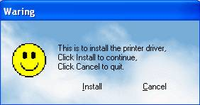
- Click “Install”
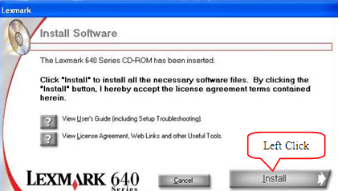
- Set the left ink cartridge as: “Color [26]”, “No, it is new”; set the right ink cartridge as: “No ink cartridge”. Then click “Next”.
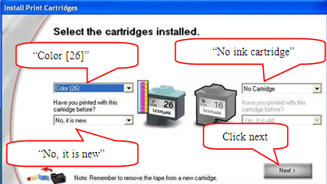
- Click “Exit” don’t print alignment page.
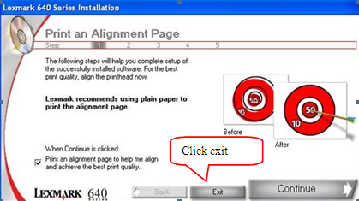

Install Gallery
- Click “Gallery”
- Click “Install”
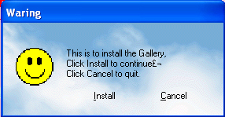
- Click “Next” and “finish”.
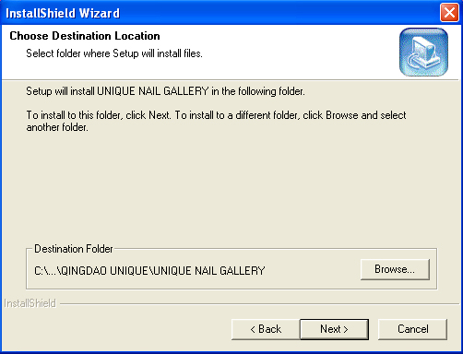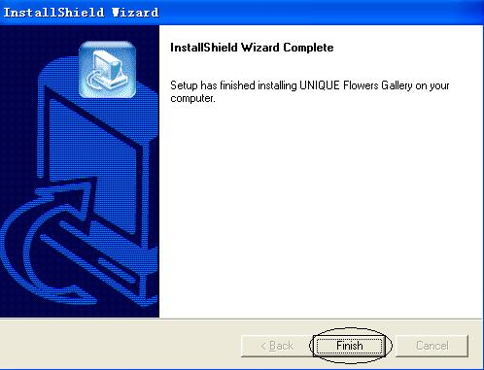

Install Software
- Click “Software”
- Click “Install”
- Click “Next”
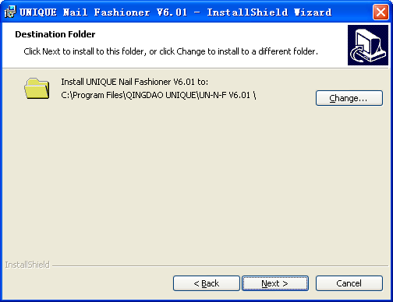
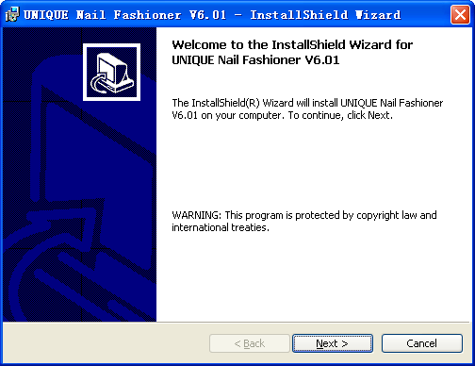
Left Click
Left Click
- Click “Install” then click finish.
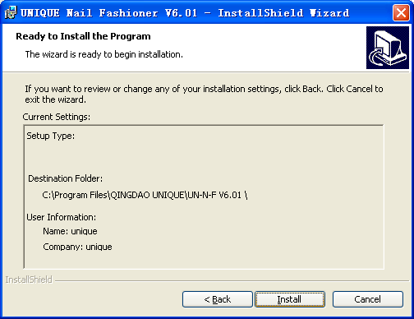
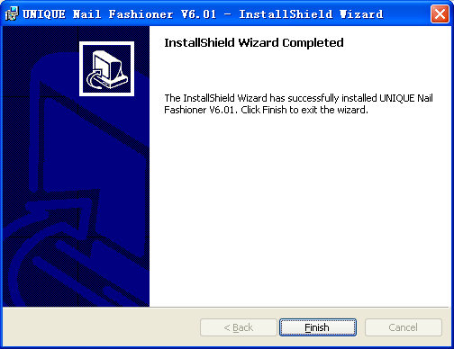
Left Click
Left Click

Close installation interface and restart computer
- Click “Exit”
- Take out the CD.
- Restart computer.

Test camera
- Open “My Computer” in start menu after restarting the computer.
- Double Click “Vimicro USB PC Camera (ZC0301PL)”

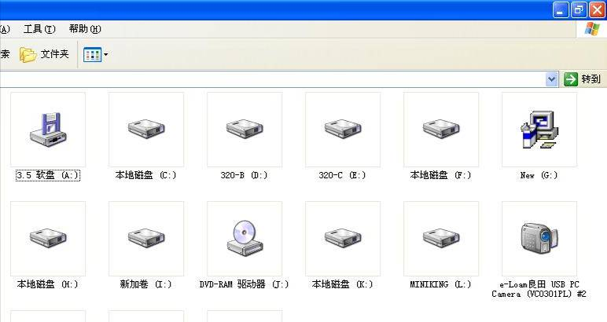
Double Click
- If you can see the normal things from camera that indicates the camera is successfully installed.
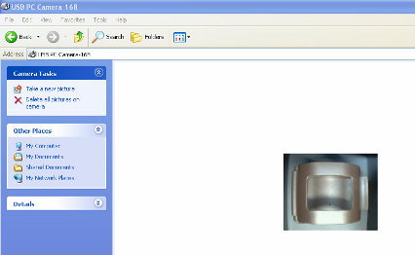
Test whether the camera can work normally
- Close the windows after finishing testing.

Printer settings
- Click “Start”, open “Printers and Faxes”
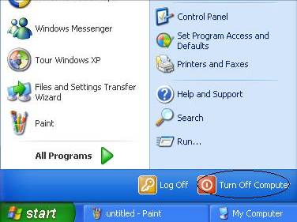
1. Click “Start”
2. Click “Printers and Faxes”

- Set default printer
  - If the “Lexmark 640 Series” is ready and already be the default printer, please go next step.
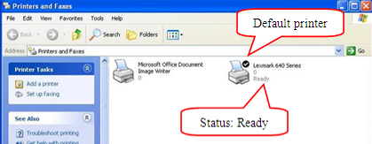
  - If you have many printers in your computer and the default printer is not “Lexmark 640 Series”, please set it as default printer.
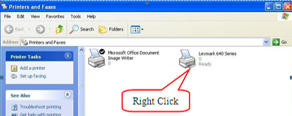
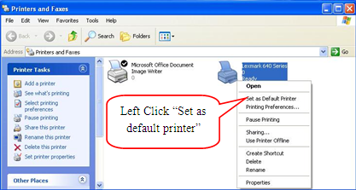
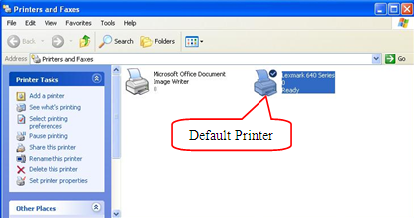
- Set printing preference
  - Right click printer icon, choose “Printing Preference’
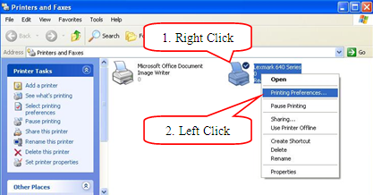
  - Set “Quality/Speed” as “Best”
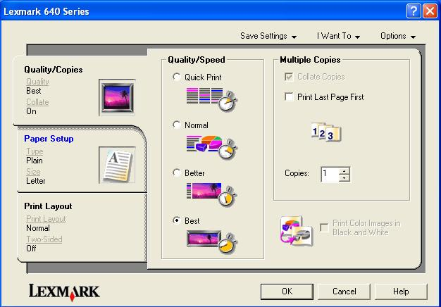
1. Choose “Best”
2. Left Click “Paper Setup’
  - Set “Paper Setup” as “Photo Glossy Paper”, set “Paper Size” as “Letter (8 1/2×11in)”, then click “OK” to save the change and close the windows.
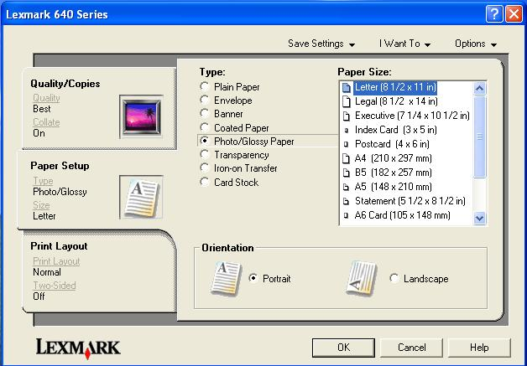
1. Left Click to choose “Photo/Glossy Paper”
2. Left click to choose “Letter (8 1/2×11in)”
3 click ok
- Close printer windows.
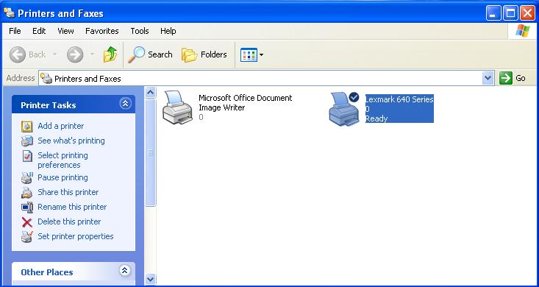
Left Click to Close

Usage
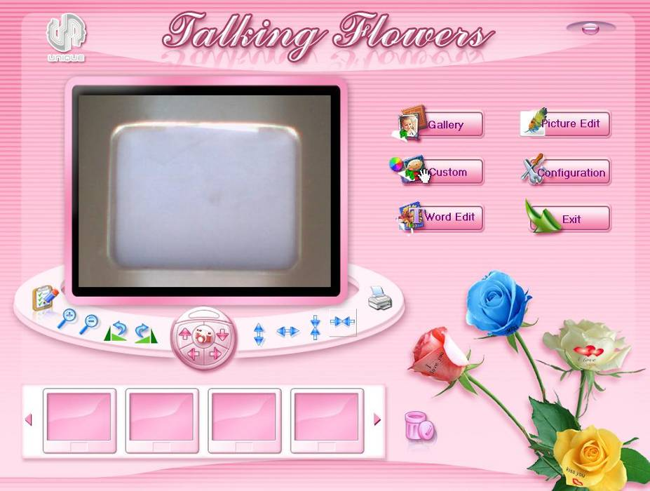
: Default images bank
: Custom images, personalized images (BMP, JPG format only)
: Word edit
: Picture edit
: Set the parameters of camera and printer, language change, password change, check printing record
: Exit program
: Original
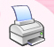: Print : Delete

Set Talking Flowers Program
- Double click Talking Flowers icon  on desktop.
- Click “”, input password (default password: 123), then click “OK”.
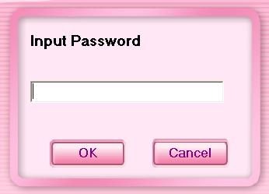
1. Input password
2. Left Click
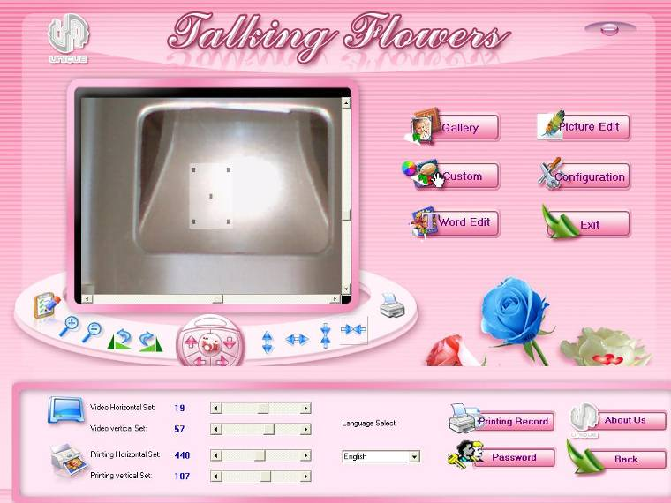
- Take off the wide board. Record the parameter on the back of wide board.
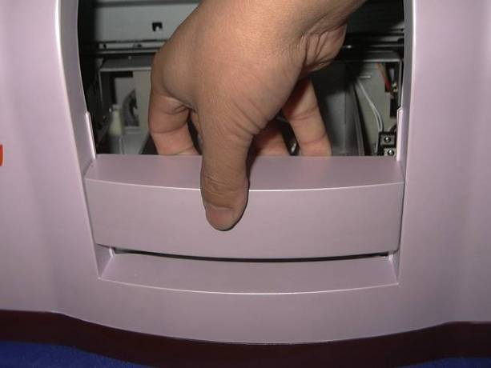
- Set “Printer Horizontal Set” and “Printer Vertical Set” according to the “Printer X” and “Printer Y” on the wide board. (“Printer horizontal Set” same to the “Printer X”, “Printer Vertical Set” same to the “Printer Y”).
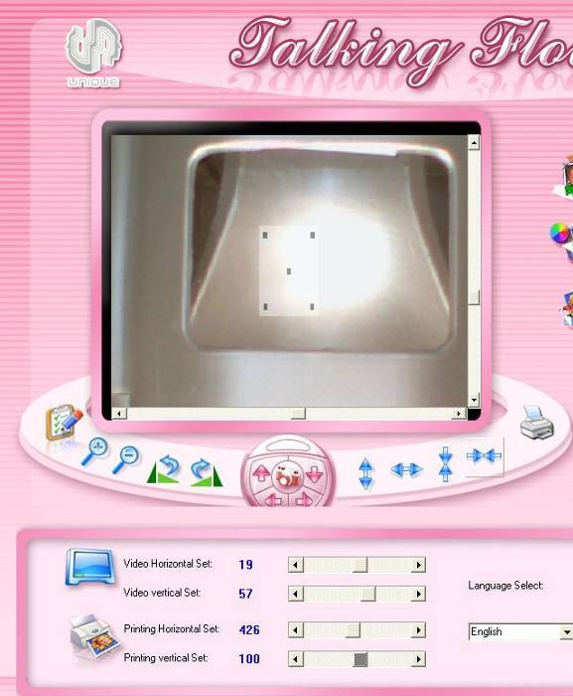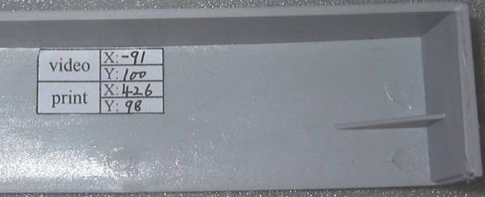
- Open the cover of flower holder
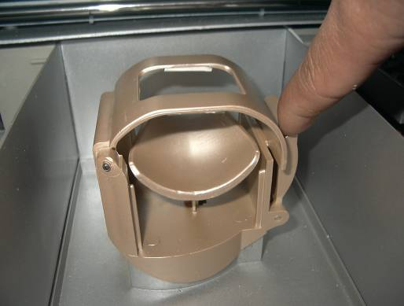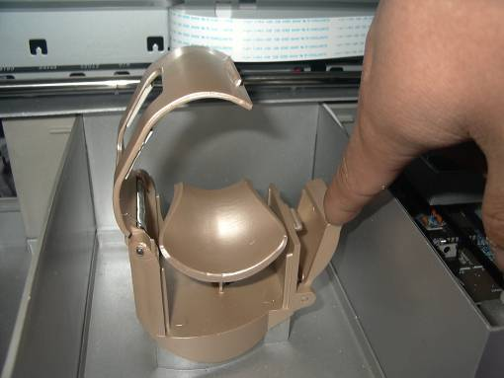
- Rolling the paper, put into flower holder, then close the cover of flower holder.
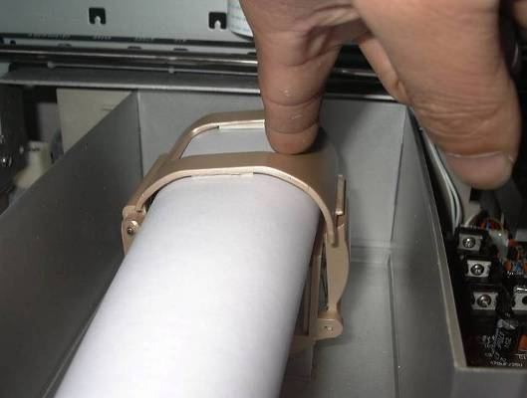
- Click “” (Original), then click “ (Print)
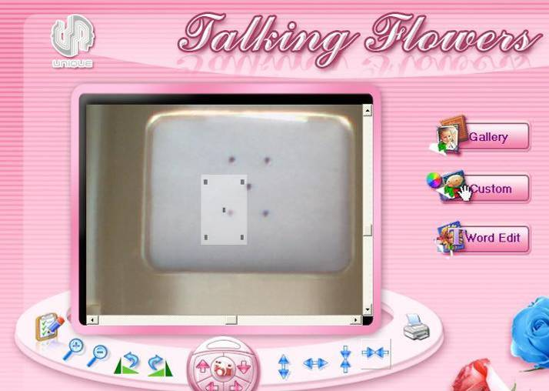
Video center
Print center
- Drag the scroll bars under and on the left of the video after finishing printing, to make sure the print center and video center are superposition. Then click “Back”.
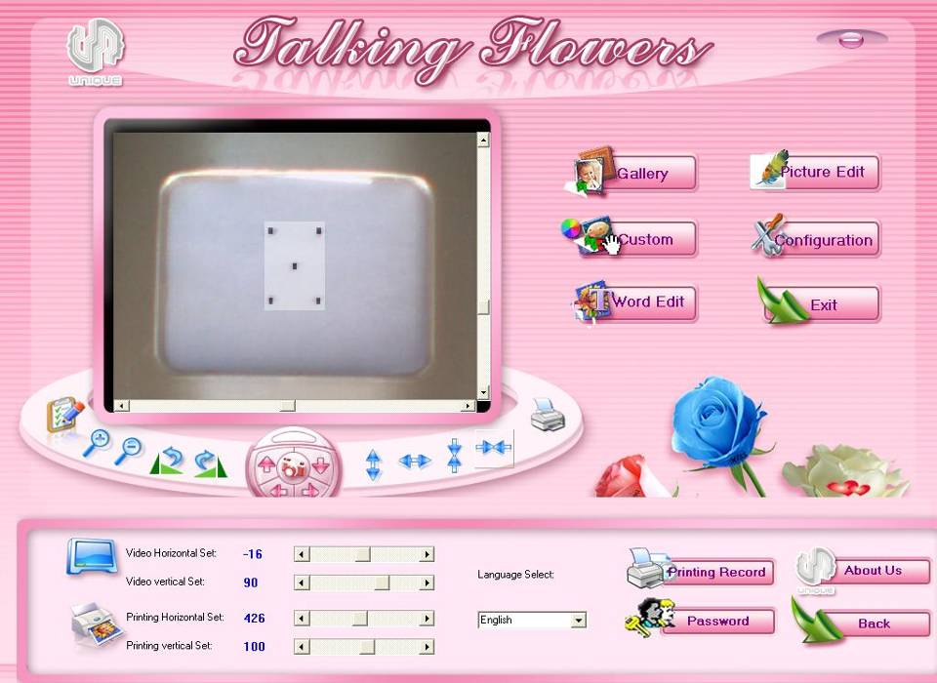
1.Drag to edit
2. Drag to edit
3. Left Click

Choose images from default gallery
- Click “”
- Click left buttons to choose the classes, and then choose your favorite images from right, you can choose more than one images at one time. Click “Back” to exit the window when finish choosing.
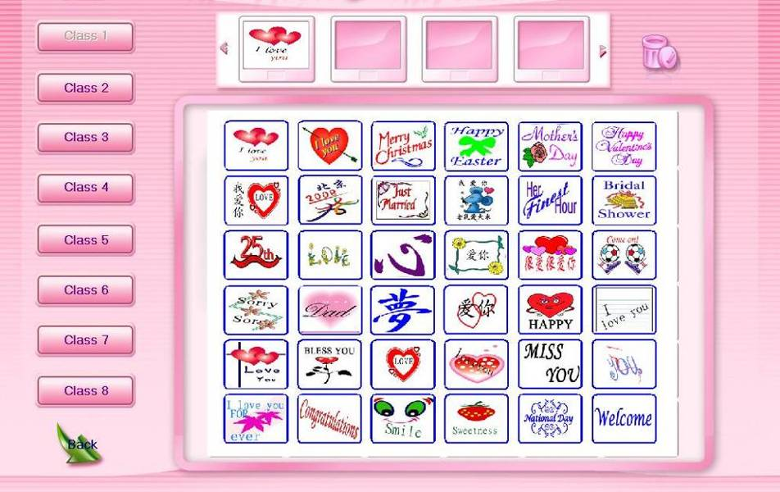
2. Left Click
1. Left Click


Adjusting images and printing
- Click chosen image, you will see from the video, see below picture.
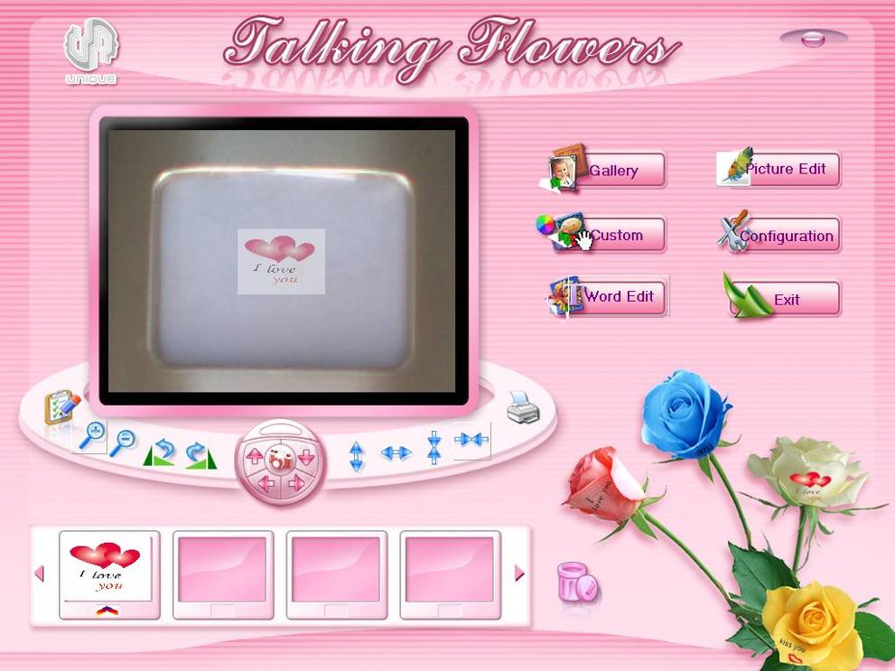
Drag left top to change the image size
Drag right bottom to change the position
Print after finishing adjusting
- Adjust images
  - Adjust angle of images
    - : 90°anticlockwise
    - : 90° deasil
  - Adjust the size and position of the images
    - : Set the image to original size and position
    - Adjust size and position of images by mouse
Drag left top of the image to adjust the size, drag right bottom of image to adjust position
    - Adjust images by buttons.
 : Enlarge : Reduce
: Turn left : Turn right : turn up : Turn down
: Increase the height : Increase the width
: Reduce the height : Reduce the width
- Click “” to start printing when finish adjusting

Preview or delete selected images
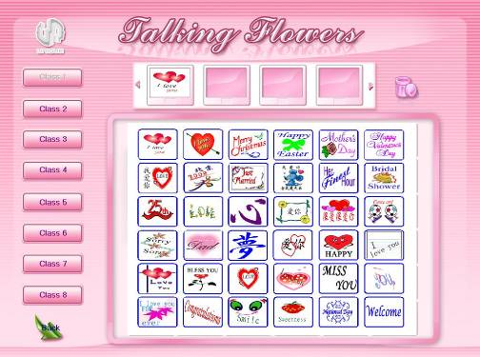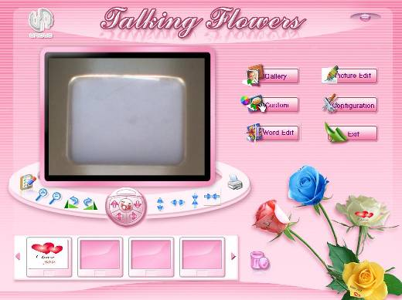

- If the selected images more than 4, please click”” “” to preview
- Delete selected images
  - Right click the images you want to delete
  - Left click the images you want to delete, then click “”

Custom images
- Click “”
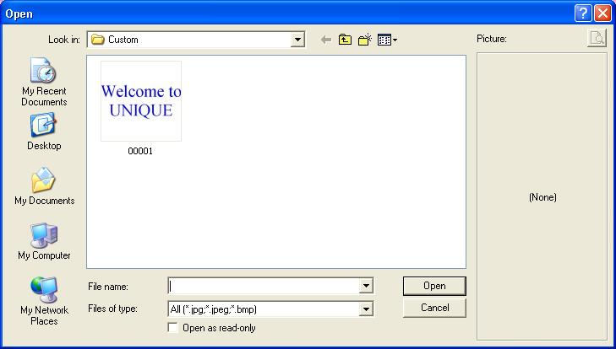
- Custom images
  - Open images in the “Custom” folder
Select images, and then click “Open”
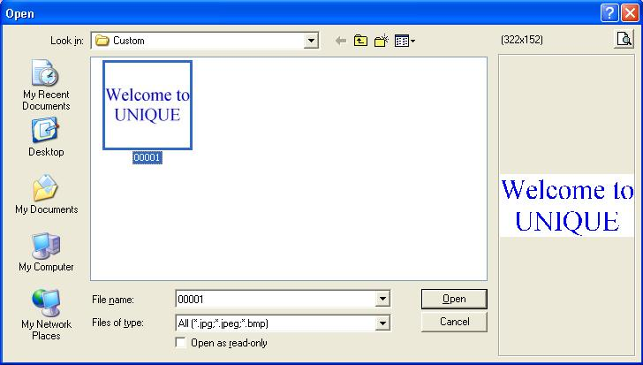
2. Left Click
1. Left click to select the image
  - Put custom images into custom gallery: Right click blank area of the dialogue, choose “Paste”, then the custom images will be saved, click “Cancel” to exit the dialogue.
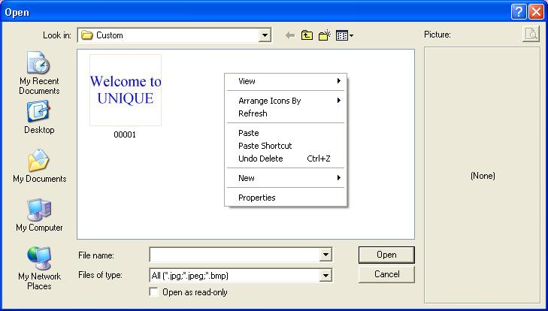
2. Left Click “Paste”
1. Right Click
3. Left Click to close

Word Edit
- Click “”
- The top blank area for previewing, bottom blank area for editing, input your personalized words from here.
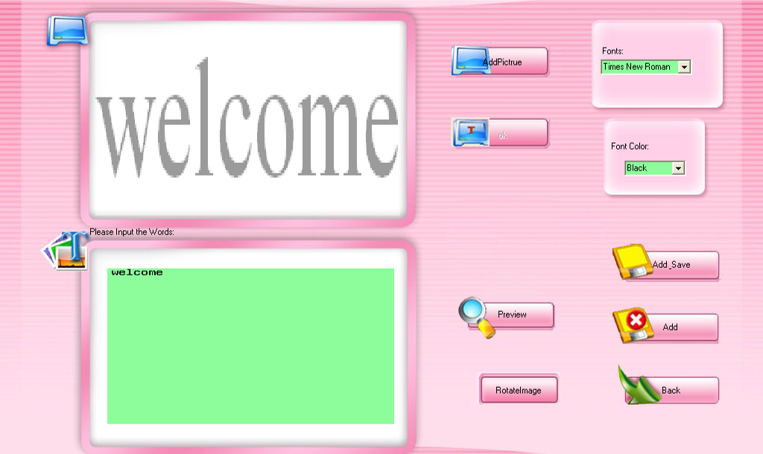
- Edit the font and color, and then click preview.：
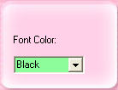
- Rotate image.
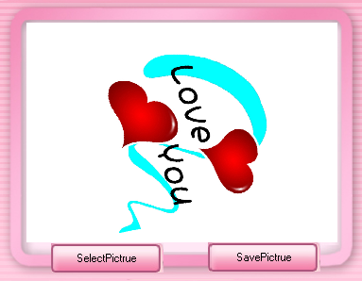

- Add words to your own picture. Input words then click to add your own picture; next click the word will cover your own picture. Drag left top of the word image to adjust the size, drag right bottom of word image to adjust position, at last click. The word has added to your own picture.
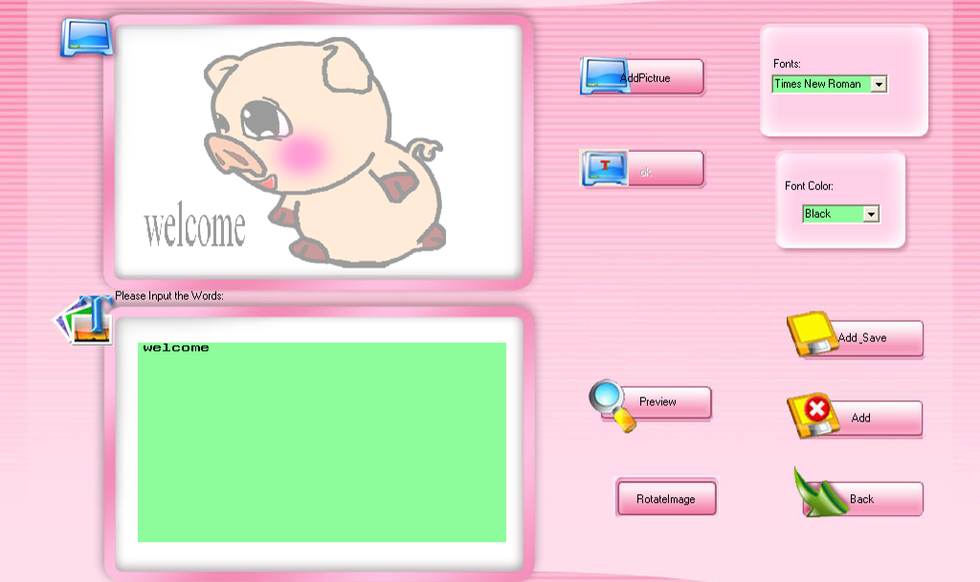
- Click “Add and Save”, input file name, then click “Save”.
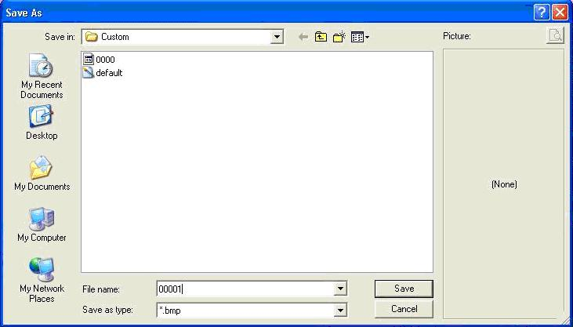
1. Input File Name
2. Left Click
- After the settings you will see the following image, and the word you edited will appear in the area of images.
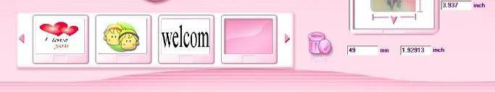

Picture Edit
Note: We provide smart and small software for you to edit pictures. In this function you can edit your picture such as Clip, Straighten, reduce redeye, auto contrast, auto color, appending some especially good effect and so on. If there is Adobe Photoshop, by which you can edit images more infectious. So if you are skilled in editing pictures by Photoshop, you can perfect your images.

- Click “Picture Edit” to start picasa2, a smart picture edit software. The first time picasa2 start it will scan images in Talking Flowers software.
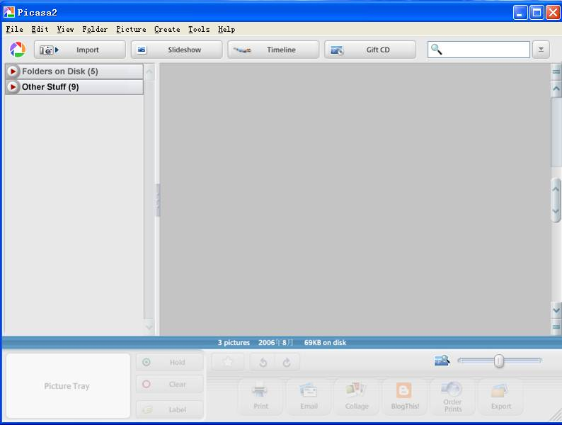
- Double click an image you want to edit and then the following interface will jump into your eyeshot. In this interface you can clip, straighten, reduce redeye, auto contrast and color and fill light by the left buttons. By the bottom button, You can turn clockwise or anticlockwise and zoom in or out
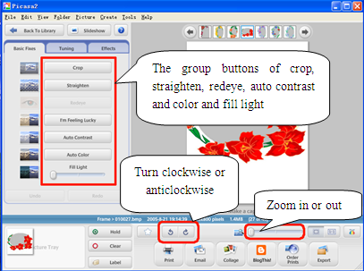
- Click the second option card—Tuning and Fill Light, Highlights, Shadows, Color Temperature are able to actualized by drag the scroll bars
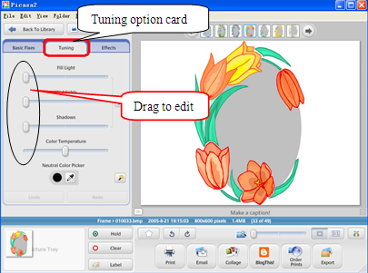
- Click the third option card—Effects, Sharpen, Sepia, Warm, mist, grain and so on effects are able to actualized by click corresponding images.
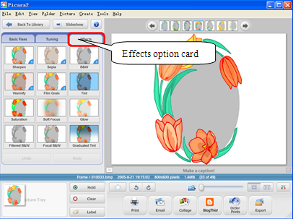
- After perfecting your images, “Export” button is able to be used as saving a copy of images that you have just perfect. You can create or rename a folder to save images
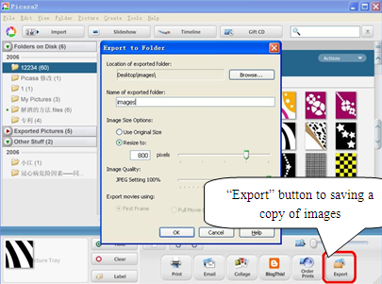

- Then you can exit picasa2, back to software main interface, click custom to find the folder just saved, which the edited images saved in. click the folder and choose your favorite images just edited.

Photo Taking
- Put up the camera
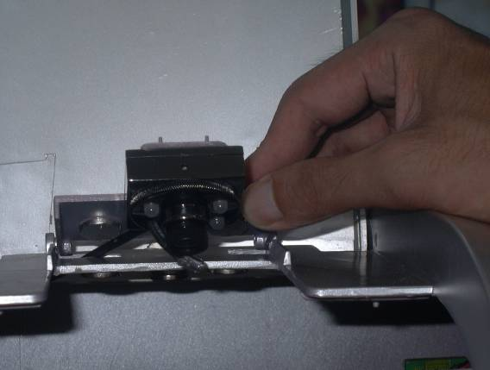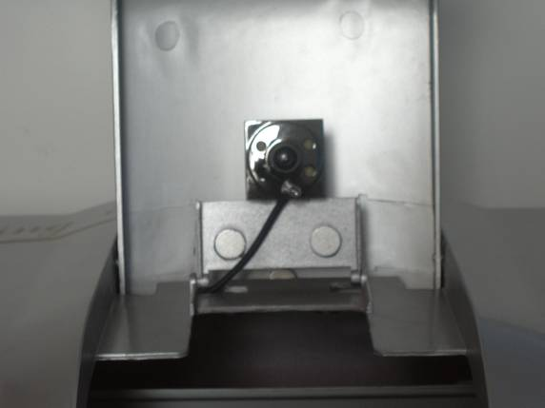
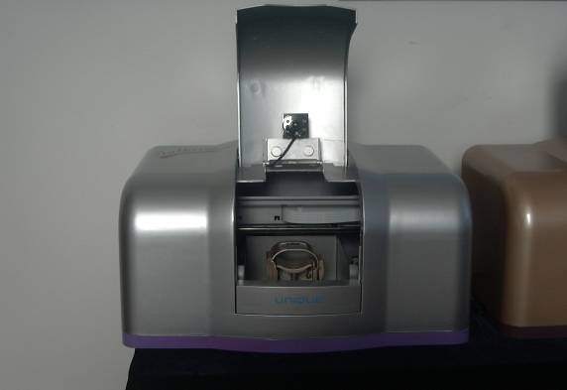
- Click  button
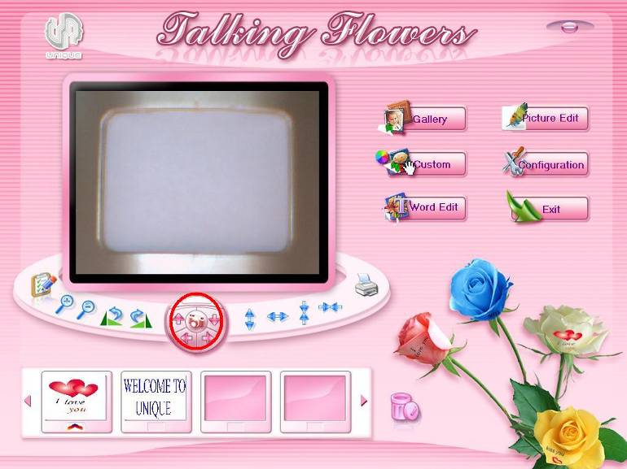
Left Click
- Click “””” to preview more frames and then click to select. Adjust and click “” to take photos. Click “Finish” when you satisfied.
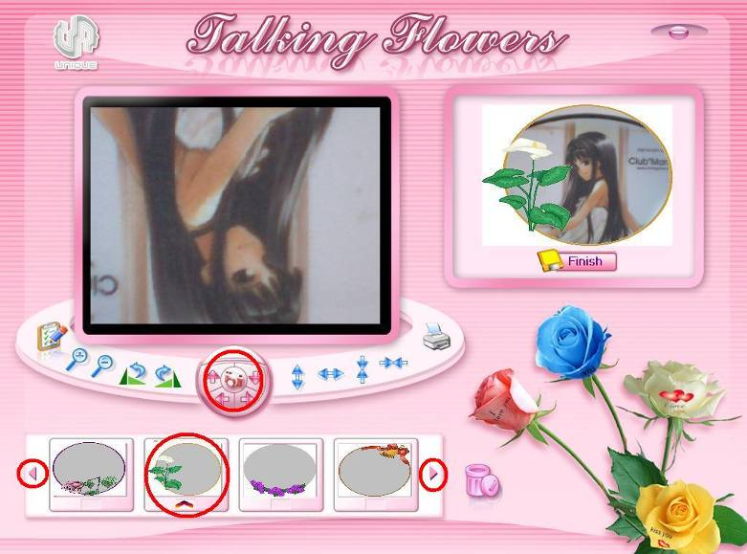
Left click to preview more frames
Left click to preview more frames

1. Click to select frames
2. Click to take photos
3. Click to finish
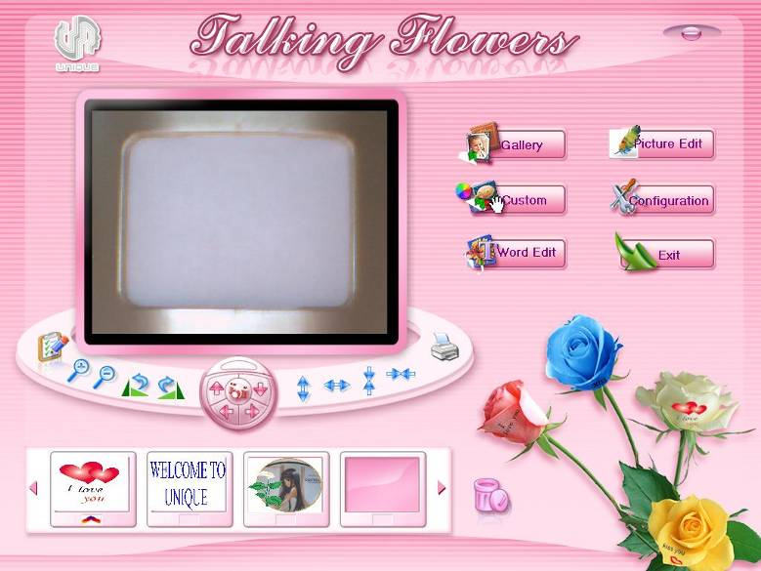

Printing
- Dip the brush into the pre coat.
- Please scrap the brush to avoid too much pre coat on it.
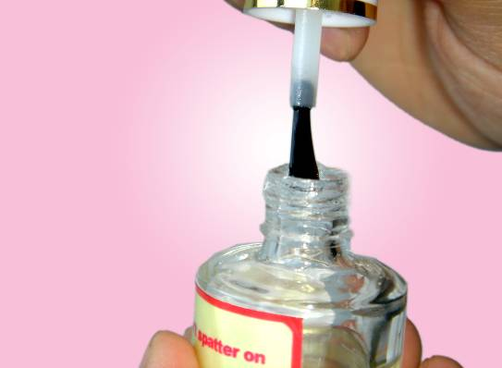

- Brush the pre coat on the petal equably
Attention:
- Brush on the petal gently and along the same direction.
- The quality of petal and equality of pre coat will influence the printing quality.
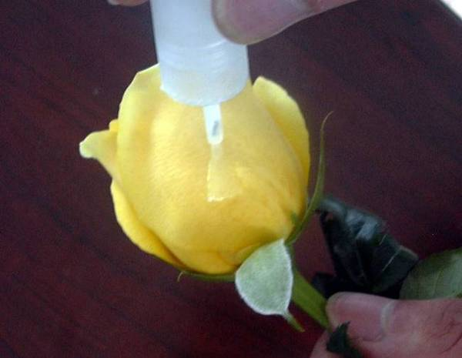
- Please make the pre coat evenly, using the sponge we specially provided.
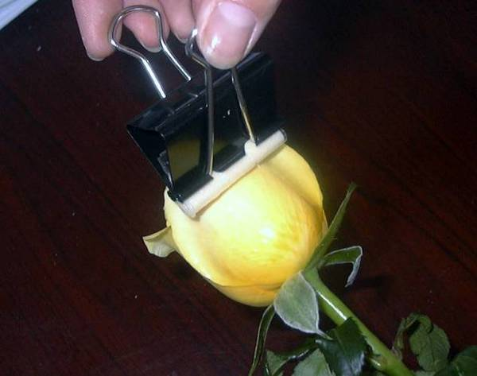
Attention: The flat of petal surface and equality of pre coat will influence the printing quality.
- Dry the pre coat naturally
  - The drying time depends on local temperature and humidity
  - The pre coat should be just dry
Attention: Don’t dry too long time; the dryness degree will influence the printing quality.
- In order to print conveniently, please take off the front wide board
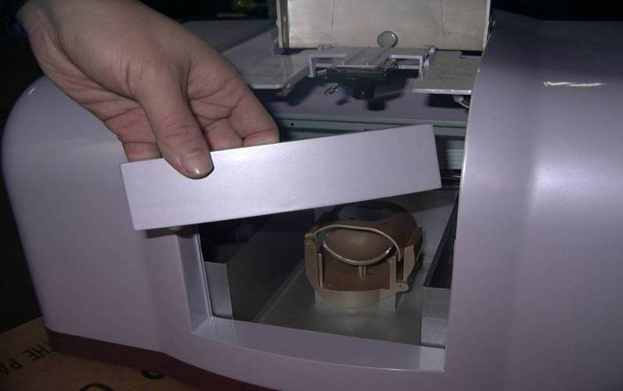
- Press “Downward” to reduce the height of the flower holder.
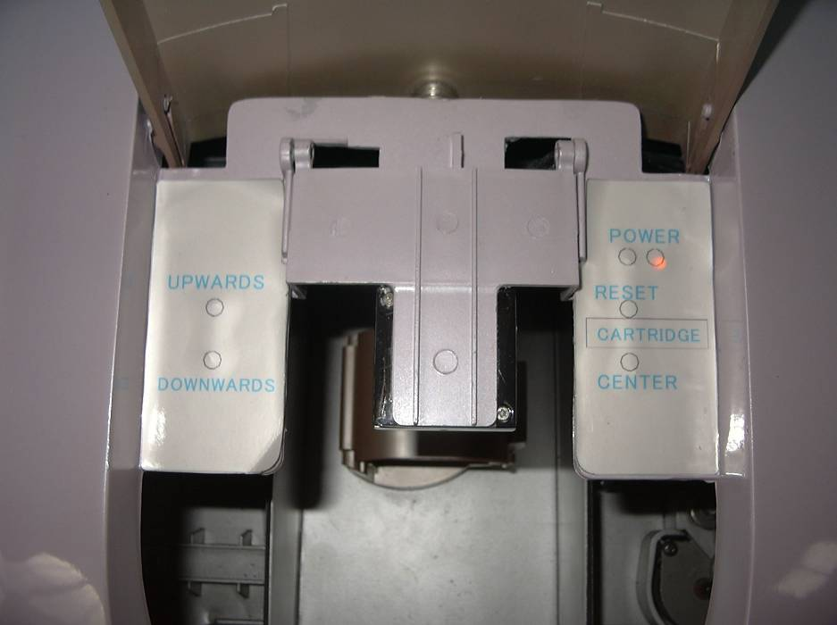
Reduce flower holder height
Increase flower holder height
- Put the flower into flower holder, close the cover and make the petal flat. Press “UPWARDS’ to increase the height flower holder, the distance between the top point of the petal and the bottom of the cartridge head is about 1.0±0.5mm. Printing when finish adjusting.
Attention:
      - Don’t nip the flower too tight when adjusting the height by “UPWARDS”.
Too tight will lead to: 1. Pre coat will stick to the holder
2. Damage the flower.
      - You should adjust the flower to make the printed petal flat after put the flower into holder. More flat the petal, much better the printing quality.
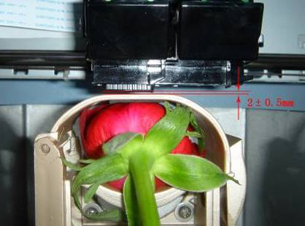

Clean and change ink cartridge
You need cleaning the cartridge if the printing color not good, and change new cartridge if use up.
- Press “Center”, the cartridge plate will move to center. Open the lid and take out the cartridge.
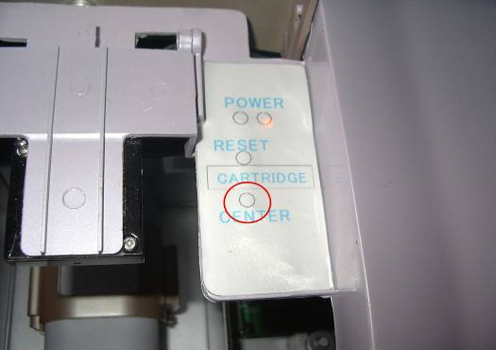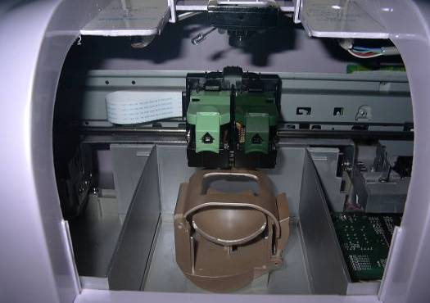
- Clean and change ink cartridge
  - Clean ink cartridge
Press cartridge head on napkin strongly until you can see very clear three colors (CMY), then put back the cartridge.
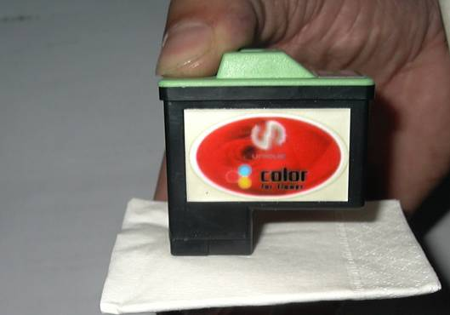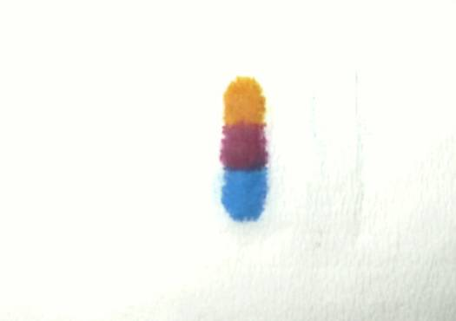
  - Change ink cartridge：
Open the new cartridge and put in the cartridge plate. (Please check “install ink cartridge” under “Install printer driver” for detail procedures).
- Close the cartridge plate lid.
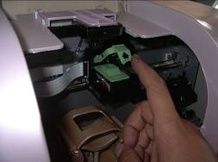
- Press “RESET”, the cartridge plate will back to original place.
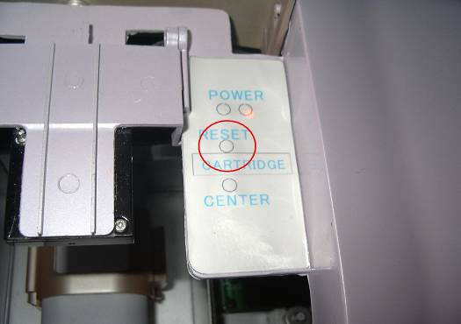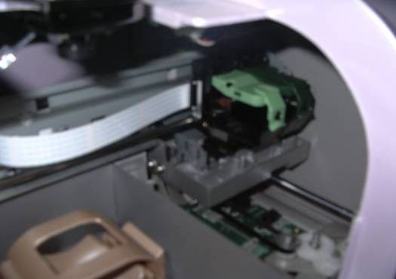
- Update cartridge information in the system.
- Double click“Lexmark 640 Series solution center”  on the desktop.
- Click “Maintenance”
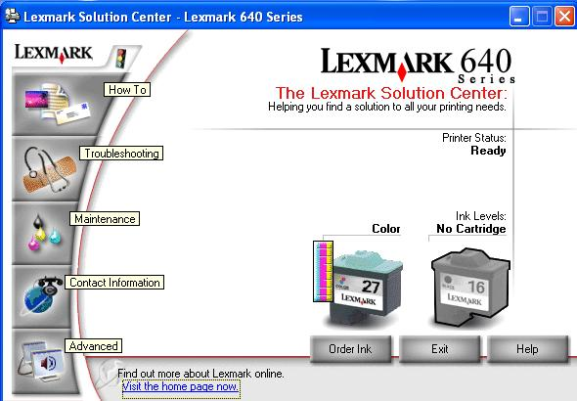
Left Click
- Click “Install or obtain a new cartridge”
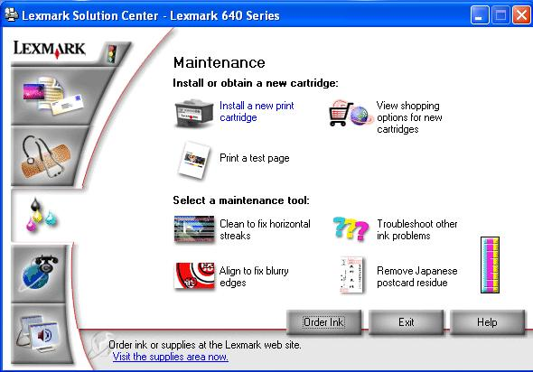
Left Click
- Click “Next” to go on.
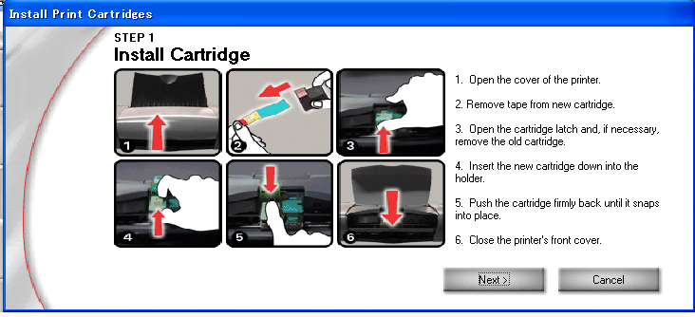
Left Click
- Choose the type of the installed cartridge.
- Set the left cartridge as “Color [26]”, “No, it is new”, set the right cartridge as “No cartridge”, and then click “Next”.
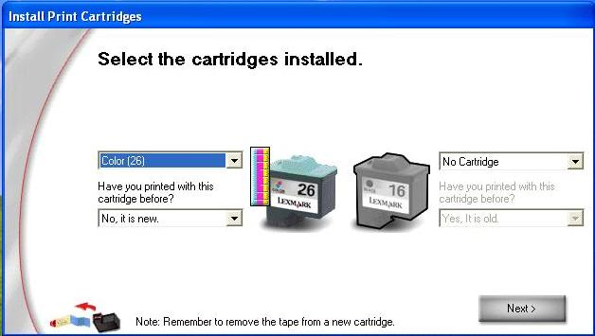
1. Set as “Color [26]”
2. Set as “No, it is new”
3. Set as “No cartridge”
4. Left Click
- Click “Exit”, don’t print alignment page.
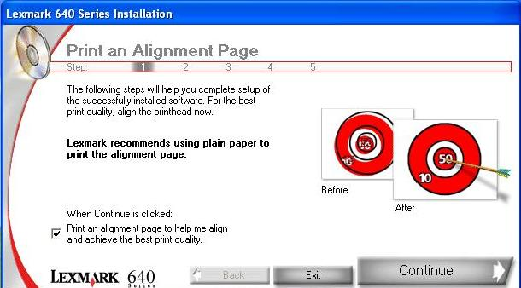
Left Click

Uninstall
Attention: Please take the camera and printer USB line off the computer before uninstalling.

Delete printer driver
Click “Lexmark 640 Series”, then click “Change/remove”
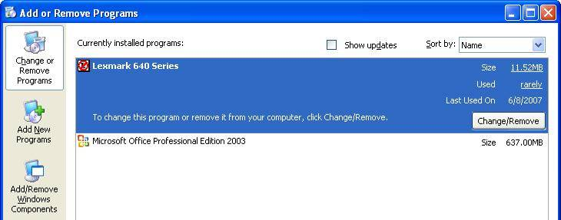
2. Left Click
1. Left Click
Click “Yes”
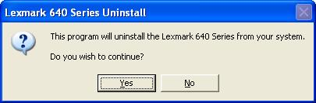
Left Click
If go on uninstall, please choose “Exit to Windows”, if only reinstall printer driver, please choose “Restart Windows now”.
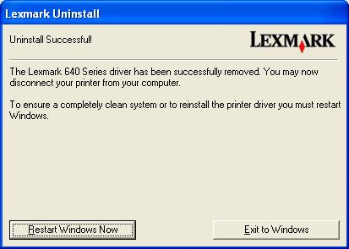
Left Click

Delete Talking Flower Gallery
- Click “UNIQUE Flowers Gallery”, then click “Change/Remove”
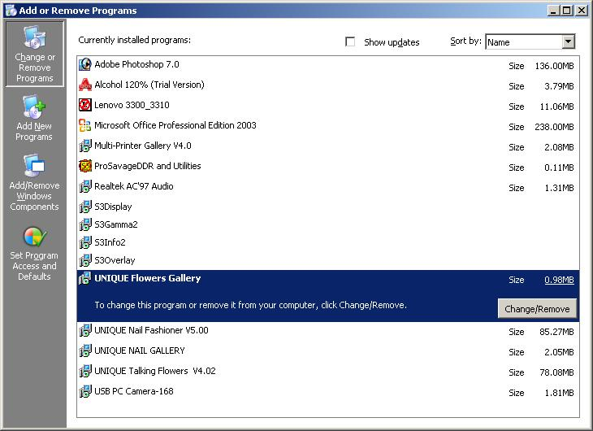
2. Left Click
1. Left Click
- Select “Remove” and click “Next”.
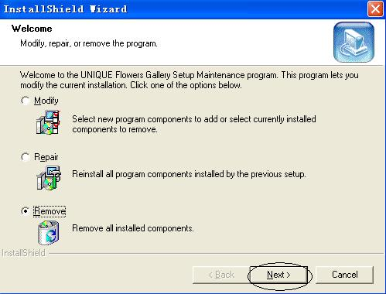
2. Left Click
1. Left click, select“”Remove”
- Click “OK”
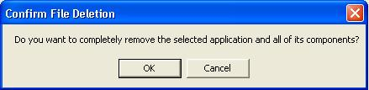
Left Click
  - Click “Finish”:
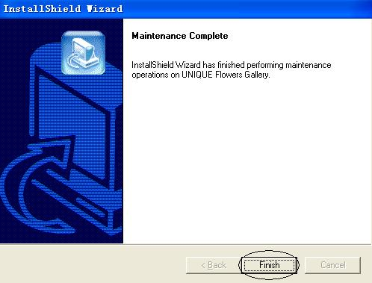
Left Click

Delete Talking Flower Program
- Click “UNIQUE Talking Flowers”, then click “Remove”
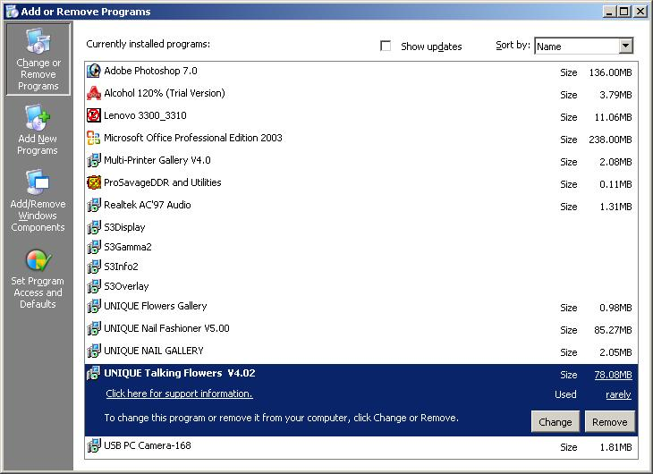
2. Left Click
1. Left Click
- Click “Yes”
Left Click

Delete Camera Driver
- Click “VIMICRO USB PC Camera(ZC0301PL)”, then click “Change/Remove”
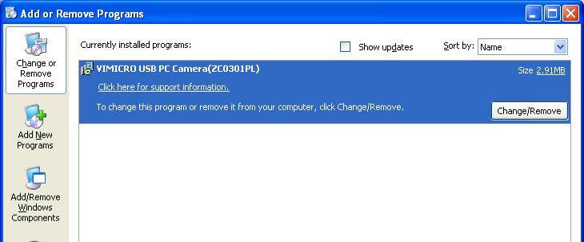
2. Left Click
1. Left Click
- Click “OK”
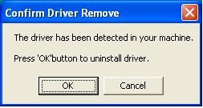
Left Click
- Click “Finish”
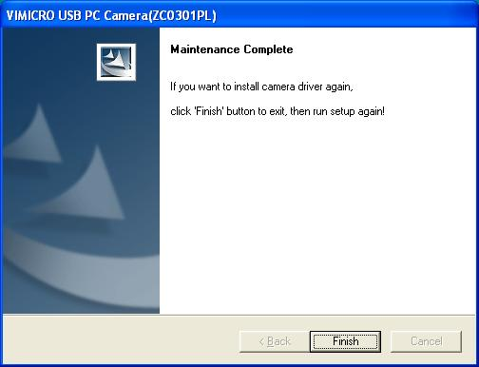
Left Click

