Hitachi Access Control Devices - Access Control Partner: Easydentic
The finger vein authentication system prevents leakage of corporate information and entry of unidentified persons into home or office buildings. This system can also be utilized in conjunction with anti-theft monitors to achieve multiple layers of security control.
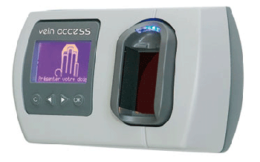
Easyvein Access
Hitachi Europe has selected Easydentic as their preferred security specialist supplier of Finger Vein Access Control Units.
The Access Control Finger Vein Reader is easy to use, compact in size and is highly reliable. It is capable of reading, verifying existing stored users.

